

ADDITIONAL INFORMATION

4/4 Short Street, Vermont VIC 3130

98 South Parade, Blackburn - (03) 9894 2044
obre.com.au/blackburn

Private Sale
$490,000 - $539,000
10% deposit, 30/60/90-day settlement
Year Built: 1970 approx
Land Size: 79m² approx
Council: Whitehorse
Council Rates: $995.55 annually
Water Rates: $230.11 quarterly
Owners Corp: $1,920.20 annually
Heating: Split System
Cooling: Split System + Ceiling Fan
Rental Details:

$470 p/w approx.

Notable Features:
- Low-maintenance living
- Fantastic condition and well-kept property
- Charming lifestyle surrounds
- Walking distance to local café’s and parklands
- Esteemed Vermont Primary and Secondary catchment

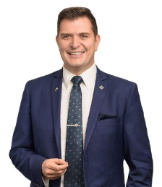
Timothy Jagger
0491 121 560
Anthony Molinaro
0411 061 796
Chattels:
All fixtures and fittings as inspected.

