

ADDITIONAL INFORMATION

2/29 Lynne Street, Donvale

98 South Parade, Blackburn - (03) 9894 2044
obre.com.au/blackburn

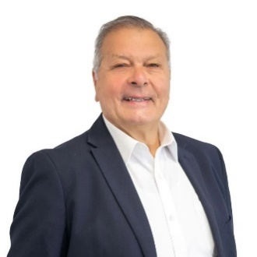

Frank Molinaro
0418 390 988
FINANCIALS 💰
Council Rates: $2,121.70 annually
Water Rates: $222.22 quarterly
Owners Corp: none
Rent Approx: $730-$780 weekly

SALE INFORMATION 📅
Settlement: 30, 60, 90 days
Tenancy: Vacant

PROPERTY DETAILS 🏡
Year Built: 2004 approx
Land Size: 233m² approx
Council: Manningham

ADDITIONAL FEATURES & NOTES 💡
Heating: Ducted
Cooling: Evaporative

Anthony Molinaro
0411 061 796
AUCTION
$890,000 - $970,000
11th October @ 10:00am | Deposit 10%

